TileVania 2D Tile-map Platformer
Section 14 Notes

Lecture 336: Where this section came from
Ben and Rick explain why TileVania has moved to this course.

Then he suggests getting the Unity Hub installed as it's useful for the different versions of Unity.
It allows us to have multiple versions of Unity installed without using workarounds or backing things up and chaos really.
Also we can have projects linked to specific versions which is very useful.

Lecture 337: New Section – TileVania!

This was just some text instructions.

Lecture 338: Welcome To TileVania

They are using 2017.3 at the start of TileVania so I'll install that version for this section.

2017.3 doesn't seem to be a recommended option to download so I'll go with 2017.4.17f1 as that's likely the most bug free version.

Lecture 339: TileVania Game Design

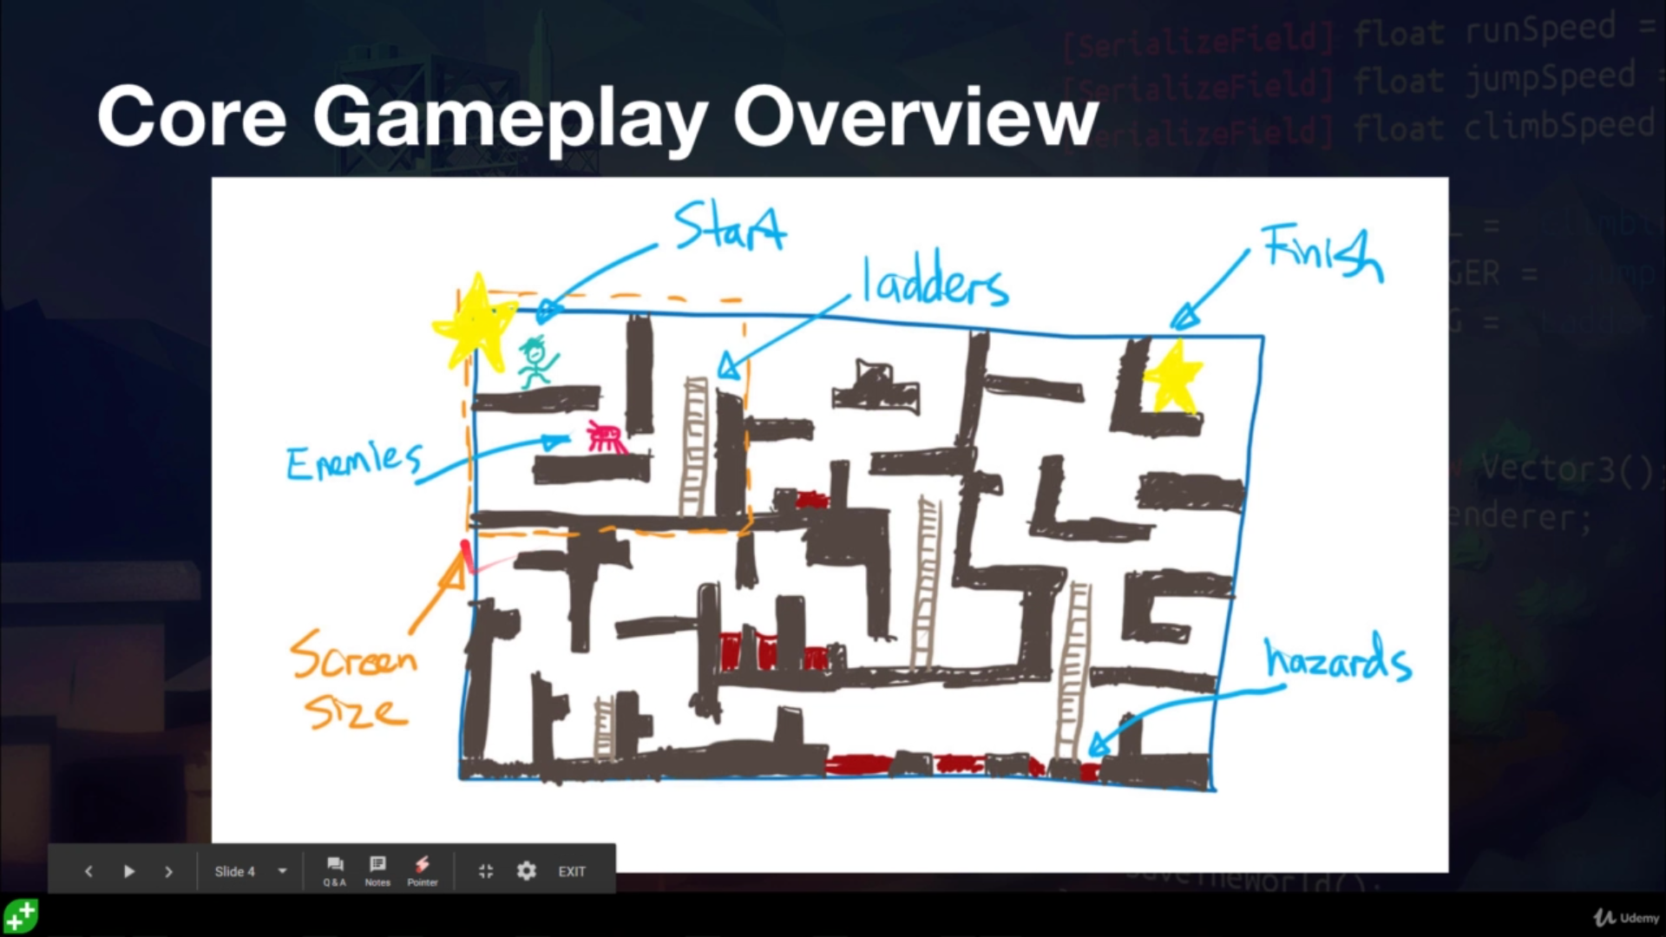

So we'll be doing stuff. Cool.

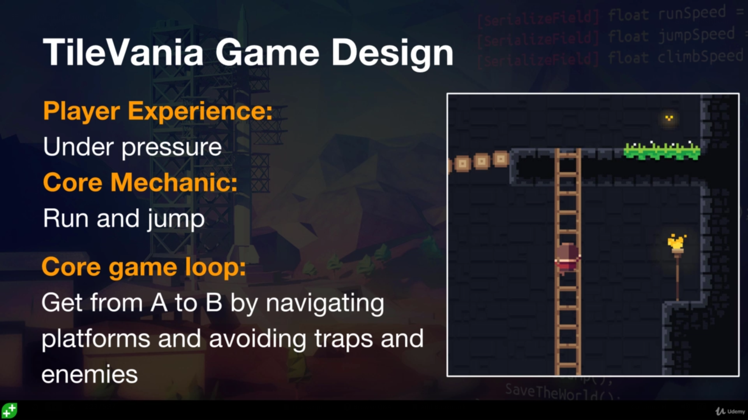
Rick's theme is to escape, you are a prisoner.

He says that there will be multiple tile map layers, background for visuals, foreground for activity like climbing ladders, the player and the enemies.

Controls will be keyboard, like Earthworm Jim, Jill Of The Jungle and so on.
Camera will snap but also follow, depending on the speed of the player.
He says there will be an automated tile painting system?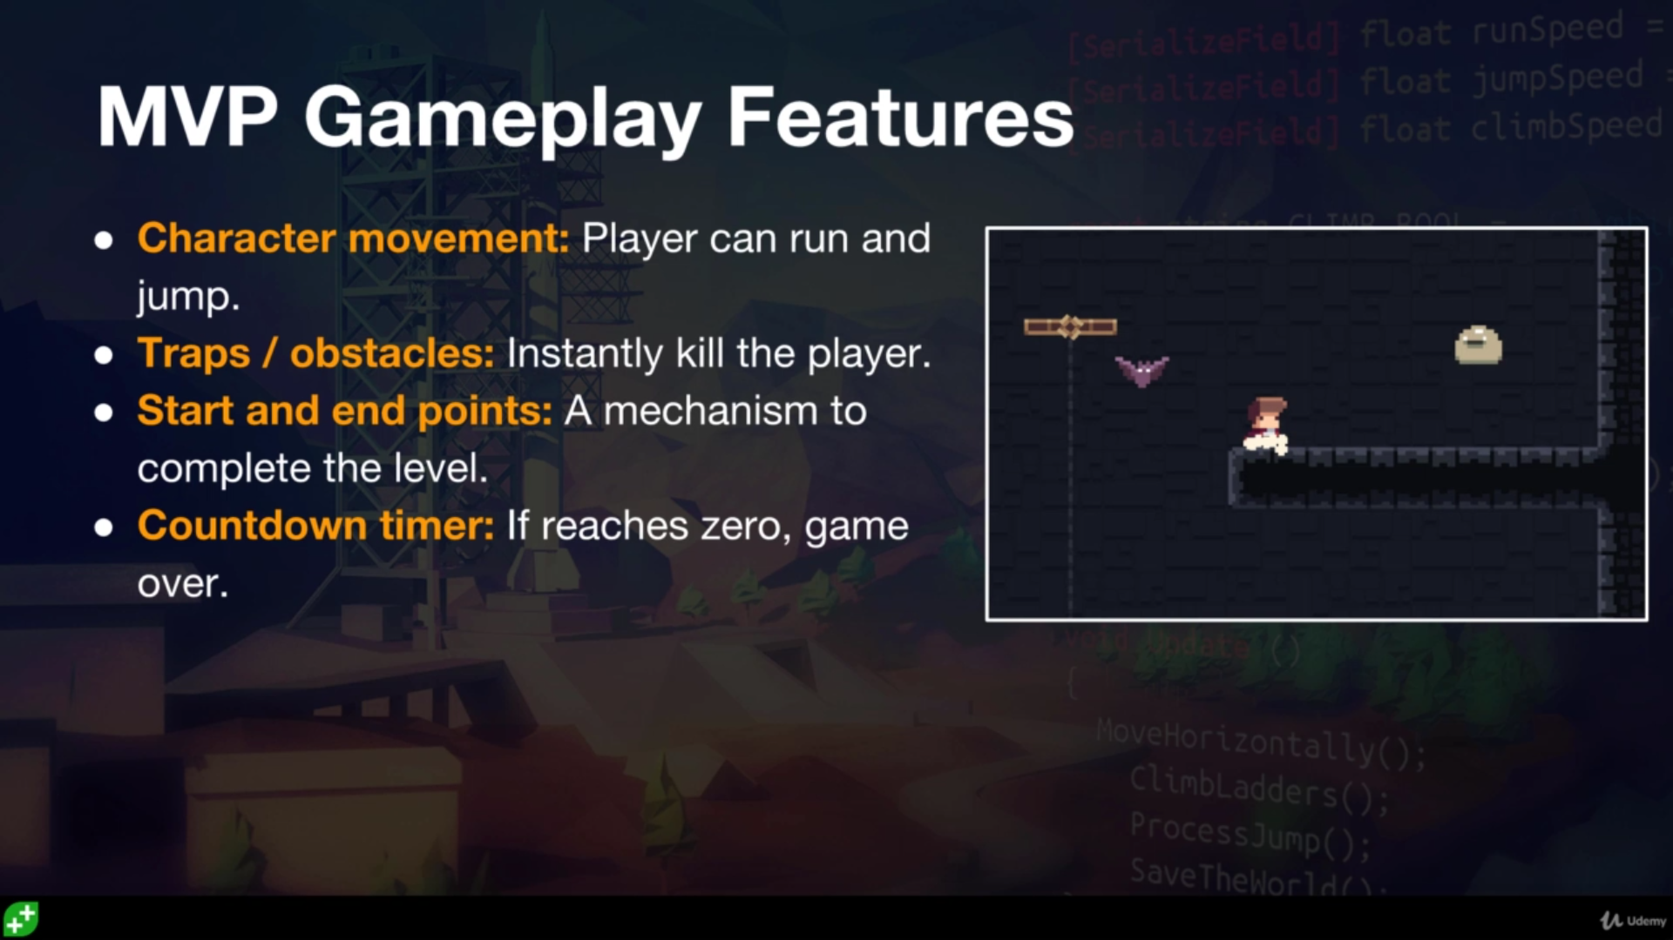
Then he sets an optional challenge.
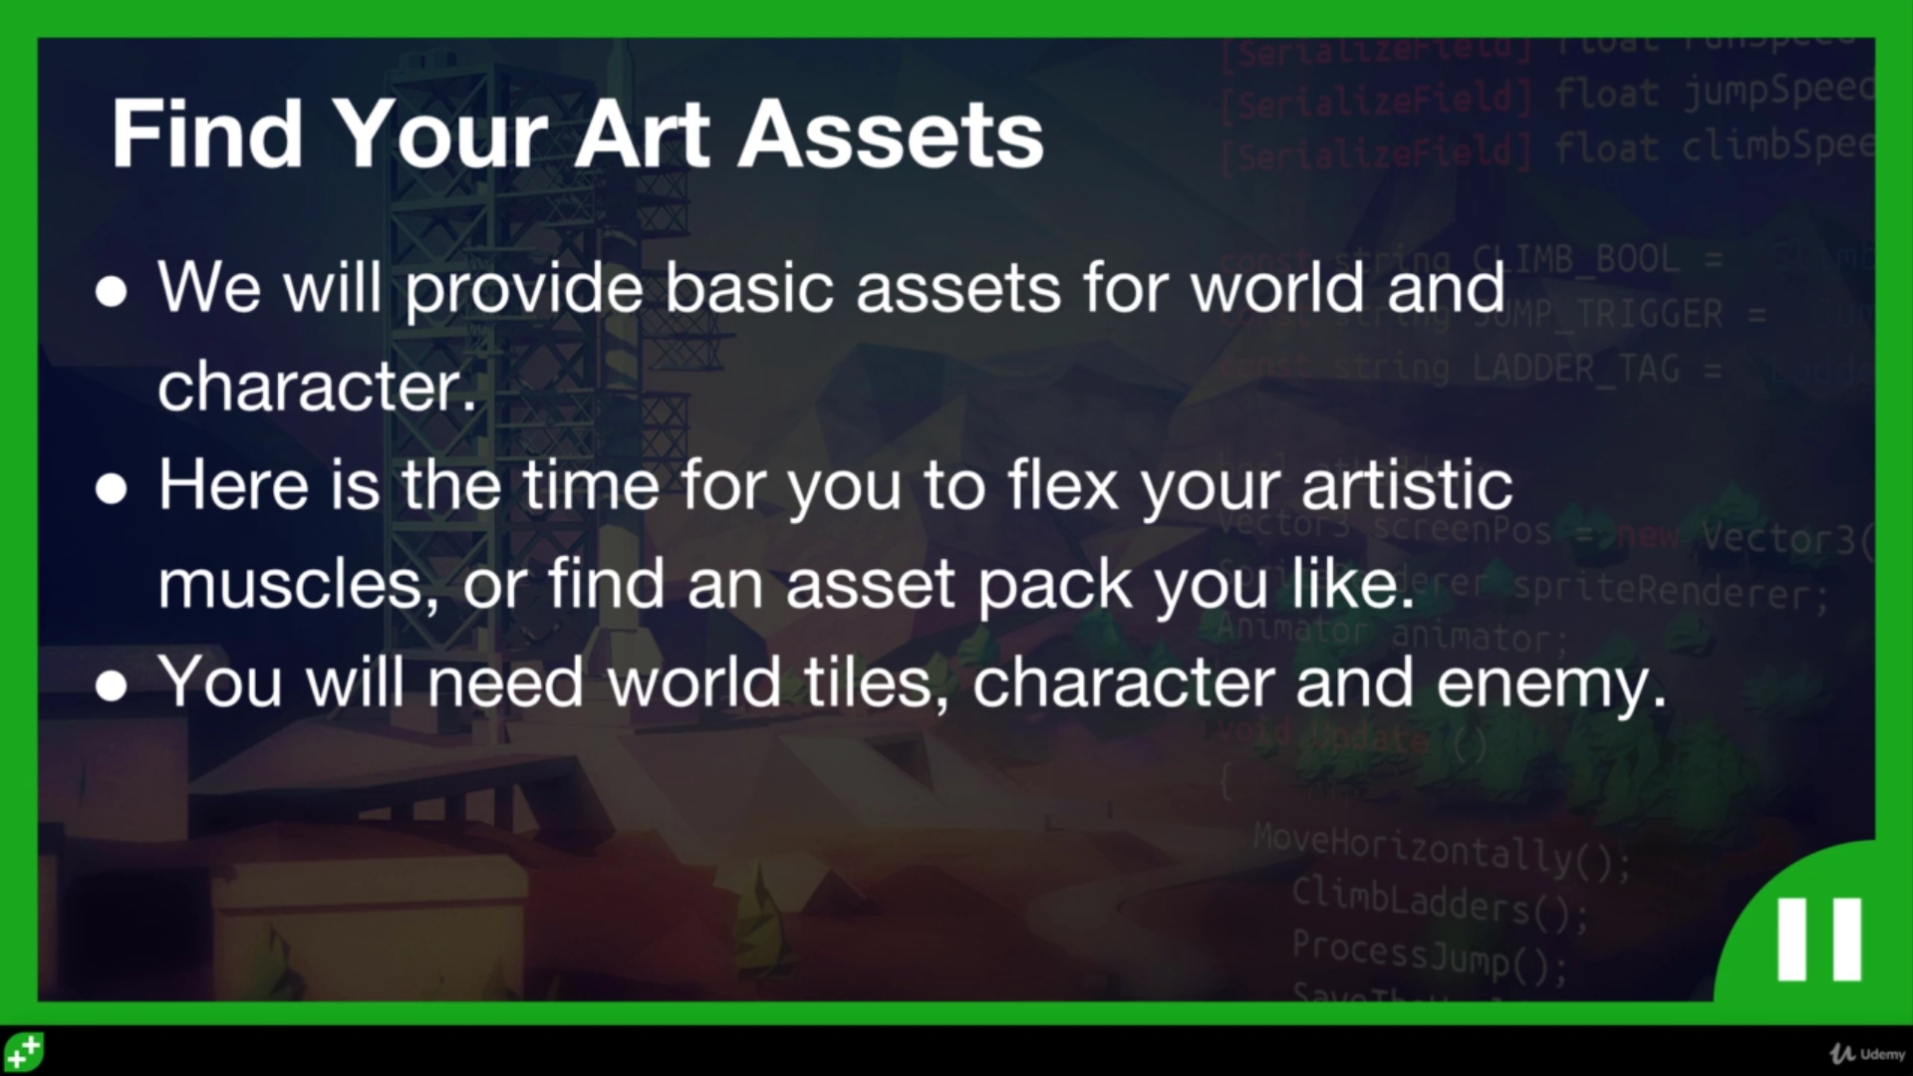
I'll see if Mike wants to have a go at making simple tile map pixel stuff.
Maybe he'd be interested in their Gimp 2 course.

I could also try this stuff:

https://opengameart.org/art-search?keys=platformer

https://kenney.nl/assets

Rick explains that we'll be using the Super Platformer Assets for this section of the course and cannot publish the game without buying the assets. Of course I could use other art from elsewhere too.

I must now decide what to do. Do I search for stuff, do I just download them? Maybe I'll download them and work through the course and if Mike wants to make some art as a test run then cool stuff.

